

**STANDARD OPERATING PROCEDURE**

**Do not Photocopy**

**Document Information Classification: Restricted**

|  |  |
| --- | --- |
| **Title:** | **Q-Pulse Administration** |
| **Effective Date:** | **16 Aug 2019** |
| **Reference Number:** | **SOP-02-07** |
| **Version Number:** | **1.15** |
| **Owner:** | **ISMS Management Process Owner,** |
| **Review Date:** | **18 Jul 2021** |

Table of Contents

1. Purpose 3

2. Scope 3

3. Responsibilities 3

4. Procedure 3

4.1. Admin Activities 3

4.2. Q-Pulse Licences 4

4.3. Security 4

4.4. Managing Records of Exiting Employees 5

4.5. Custom Reports 5

4.6. Document Distribution 6

4.6.1. Copyholders Template 6

4.6.2. New Major Document Version Distribution 10

4.6.3. New Minor Document Version Distribution 11

4.6.4. Managing New Starters 12

4.6.5. Managing Role Changes 12

4.7. Managing The Release of New Document Versions 12

4.8. Document Approval Templates 14

4.9. eMail Notification 14

4.9.1. eMail Considerations for External TRE Users 15

4.10. Testing and Change Control 15

4.10.1. Q-Pulse Testing 15

4.10.2. Q-Pulse Change Control 16

4.11. Configuration Changes 16

4.11.1. Managed Lists, Custom Fields and Preferences 16

4.11.2. Wizards and Templates 16

4.12. Managing Audit Records 16

4.12.1. Internal Audits Scope Items 16

4.12.2. RMM Audit Checklists 17

5. Cross-referenced ISMS Documents 17

6. Appendices 17

1. Purpose

Operating procedures should be documented and made available to all users who need them.

This document provides guidance for the administration of Q-Pulse and any specific configurations that have been created to support the ISMS.

1. Scope

The administrative activities necessary to support Q-Pulse that are additional to standard Q-Pulse functionality are in the scope of this document.

All non-standard configurations are also described in this document.

User processes are out of scope of this document.

Installation configuration activities are out of scope of this document

Further details regarding the use of Q-Pulse and all of the administrative functions can be found in the Q-Pulse V6 help contents accessible from the Q-Pulse client.

1. Responsibilities

The Q-Pulse administrator is responsible for:

* Managing the administrative activities

1. Procedure
   1. Admin Activities

The key admin activities for the Q-Pulse administrator will be as follows:

Provide data to support monthly reporting including:

* Non-conformities and corrective actions
* Monitoring and measurement results
* Internal audit results
* Fulfilment of information security objectives

Add new starters and provide user ID and password information

Archive leavers following the completion of the exit checklist

Manage document activation and distribution.

Manage changes to the Q-Pulse configuration including:

* Wizards and Templates
* Managed Lists and Custom Fields
* Security Model
  1. Q-Pulse Licences

Basic users will mostly be using the Q-Pulse web client and should be assigned a secondary licence. Advanced users (e.g. document owners, Asset administration) will be using the Windows client and should be assigned a primary licence.

Since secondary user licences are limited and users don’t always log off cleanly it will be necessary (~weekly) to check for active sessions (via the Administration module) and log off inactive sessions.

* 1. Security

Security is managed using Dynamic and Static security groups. The dynamic groups assign permissions to users fulfilling a particular role e.g. a document owner and are specific to the individual record to which they have been assigned that role. The static security groups can be used to easily apply groups of permissions to one or many individual users and are effective across the whole system, not just where the user has been named in a particular role. Permissions may also be applied directly to individual users but this is not recommended.

e.g. The Document Read permission applied through the Copy Holders dynamic group will only allow users to read the documents for which they are assigned as copy holders.

The Document Read permission applied as a static group or directly as a permission to an individual user will allow that user to read all documents in the Q-Pulse system.

There are currently 10 static security groups within Q-Pulse and all users will be assigned at least one of these groups depending upon job role and responsibilities.

|  |  |
| --- | --- |
| **Role** | **Description** |
| CHI Basic user | Basic user role applied to all Q-Pulse users providing the necessary access for the majority of users |
| CHI Process Owner | Access necessary for Process Owners to manage their process documents. Not specific to any particular process. |
| System Administrator | Q-Pulse Administrator |
| CHI Audit Management | Access for Lead Auditors to allow the creation and management of Audit records |
| CHI Line Managers and Supervisors | Access for line managers and people responsible for the supervision of staff, allowing access to the People records for their reports |
| CHI Admin - People | To allow management of the People records |
| CHI Admin - Assets | To allow management of the Asset records |
| CHI Training and Competency Management | To allow management of the Training and Competency records |
| CHI Supplier Management | To allow management of Suppliers |
| CHI Board | To allow the CHI Board to view all documents and raise CRs |
| CHI Event and Incident Management | To allow Incident Investigation Team and ISMS Improvement Team to manage Actions |

Full details of the security model can be found here:

[Q-Pulse Security Model](https://elab.herc.ac.uk/share/page/site/tre/document-details?nodeRef=workspace://SpacesStore/4cafd533-7317-4055-82f3-fec9d2baebe6)

If a user cannot access the service they require and it has been agreed by the ISM that this access is necessary the following short process steps should be followed.

1). What does the person need to do as part of their role?

2). Is this consistent with everyone else in the role?

If yes:

3). Add the permission to the access group for the role to allow this access

If no:

3) Define a new security role.

4) Add the necessary permissions to that role.

After the changes are complete the security model documentation in elab should be updated to reflect the change.

* 1. Managing Records of Exiting Employees

When employees are exiting the organisation the Q-Pulse administrator should be notified by the person’s line manager or CHI Staff Administration.

The steps necessary to close the person record are as follows:

* Disable Q-Pulse Login. This should be completed as close to the leaving date as possible
* Remove the person from any Reference Groups and Copy Holder templates
* Ensure all assets have been re-assigned (it is not the administrators responsibility to re-assign the assets).
* Ensure the exit checklist has been attached to the person’s record.
* Archive the Account.
  1. Custom Reports

The following additional reports have been created in Q-Pulse.

|  |  |  |
| --- | --- | --- |
| **Module** | **Name** | **Purpose** |
| Documents | Related Documents | To show the documents that are linked (via the Q-Pulse properties) to each primary document. |
| Documents | Revision History | Shows all document versions and the Change Details recorded with each version |
| Documents | Review Due Dates | Shows the due dates for document reviews. Overdue reviews are highlighted red. Reviews due within the next 2 months are shown red. Reviews due with the next 3 months are shown amber. |
| Documents | Change Requests | All CRs by document, including status and document version when they were implemented |
| Documents | Change Request Detail | All CRs by document, including status, CR response comments and document version when they were implemented |
| Documents | Admin - Review Date Checker | To check that review dates have been correctly set |
| Documents | New Change Requests | New change requests |
| Documents | Draft Documents Awaiting Approval | To provide details of the draft documents awaiting approval |
| Documents | Approval History | History of all document approvals |
| Documents | Document Review Comments | Comments added during a document review |
| Documents | Exception Report - New CRs | New change requests awaiting review. Highlighted when review has been outstanding for more than 2 months. Should be executed with search filter applied to the document list. |
| Documents | All Acknowledgements (current version only) | All document acknowledgements of the current version of a document |
| Documents | Exception Report - CRs Awaiting Implementation | CRs approved but not yet implemented |
| Documents | Copy Holders and Document Acknowledgements* | To show all document copy holders and completed acknowledgments |
| Documents | Notified User Distribution List | To show all notified users for a document |
| Documents | Admin – Document Acknowledgements | Basic report showing all document acknowledgements used for monthly reporting |

*Set as default report - a default report is the report which is printed whenever the user clicks the print and preview  icons at the top of any list or details view. Each module's list / details view can only have one default report each.

Note: other custom reports may also be available but these are not directly used in monthly or status reporting

* 1. Document Distribution

Document distribution will primarily be managed through the use of the Copyholder Templates.

* + 1. Copyholders Template

The Copyholder templates have been created as follows:

|  |  |
| --- | --- |
| **Distribution Group (Process Owner)** | **Copyholder Template Name** |
| All CHI Staff/Students at VH, JMF or CityLabs | All Staff and Students {R} |
| All ISMS Process Owners | Process Owners {R} |
| All Line Managers/Supervisors | Line Managers {R} |
| CHI Staff Administration (JA) | CHI Staff Administration |
| Communications and Marketing (SM) | Communications and Marketing |
| Education and Training (EG/KoM) | Education and Training |
| IG and Data Management (EG) | IG and Data Management |
| ISMS Internal Auditors | Internal Auditors {R} |
| ISMS Improvement (CSP) | ISMS Improvement |
| ISMS Management (MM) | ISMS Management |
| ISSG (JA) | ISSG |
| Public Engagement and Ethics (MT) | Public Engagement and Ethics |
| Research (NP) | Research |
| Software Engineering (MM, PC, PW) | Software Engineering |
| TRE Operations (BG) | TRE Operations {R} |
| TRE Project Board (BG) | TRE Project Board {R} |
| TRE Sys-Admin (PC) | TRE Sys-admin {R} |
| TRE Users – Internal (BG) | TRE Users - Internal |
| TRE Project Members – Internal (BG) | TRE Project Members - Internal |

{R} Reference Group also created

(XX): Initials of responsible manager

The Copyholder templates that will be applied to each document to create the necessary distribution lists are defined in the table below (see ISMS-02-11 for details of the document distribution settings).

|  |  |  |
| --- | --- | --- |
| **Document Number** | **Document Title** | **Distribute to Copyholder Templates** |
| DIAG-001 | TRE Network Schematic | TRE Sys-admin |
| FORM-002 | TRE Project Application Form | Line Managers (notified only)  TRE Operations |
| FORM-004 | New starter and leaver asset and IT account checklist | Line Managers  CHI Staff Administration (Notified only)  New starters |
| FORM-005 | Request for Access to Vaughan House Secure Zones and Security Resources | Line Managers (Notified only)  CHI Staff Administration (Notified only) |
| FORM-006 | TRE Incident Investigation Report | IG and Data Management |
| FORM-007 | TRE Project Service Request Form | TRE Users – Internal (notified only) |
| FORM-008 | TRE Request for Change | TRE Project Board  TRE Sys-admin |
| FORM-009 | TRE Visitors Access Form | All Staff and Students (Notified only) |
| ISMS-01-04 | Guidance for new CHI staff and students | Line Managers  New starters (not a template)  All staff and students (notified only) |
| ISMS-02-02 | Stakeholder Analysis | Communications and Marketing |
| ISMS-02-03 | Index of relevant policy | ISSG |
| ISMS-02-04 | ISMS Role Assignments | ISSG |
| ISMS-02-05 | Risk Management Process | ISMS Management  ISSG |
| ISMS-02-06 | Information Security Risk Register | Will be reviewed at ISMS Management Review so will not be distributed. |
| ISMS-02-07 | ISMS Roles and Responsibilities | ISSG |
| ISMS-02-08 | ISMS Document Acknowledgement and Digital Signing | All Staff and Students (will be superseded by SOP-02-06 for new starters) |
| ISMS-02-09 | Authorisation of ISMS | ISSG (Notified only) |
| ISMS-02-10 | ISMS Manual | ISSG |
| ISMS-02-11 | Controls Statement of Applicability | ISSG |
| ISMS-02-12 | Information Security Measures | ISSG |
| ISMS-03-02 | TRE User Clear Screen and Desk Policy | *TRE Users - External  TRE Users – Internal |
| ISMS-03-03 | TRE Business Continuity and Information Security Continuity Plan | TRE Operations |
| ISMS-03-04 | Responsibilities for TRE Unmanaged Projects | TRE Operations |
| ISMS-03-05 | TRE Bring Your Own Technology Policy | *TRE Users - External  TRE Users – Internal |
| ISMS-03-06 | TRE Supplier Relationship Policy | TRE Operations |
| ISMS-03-07 | TRE Password Policy | *TRE Users - External  TRE Users – Internal  TRE Sys-admin |
| ISMS-03-08 | TRE Maintenance Policy | TRE Operations |
| ISMS-03-12 | TRE Roles and Operational Guidelines | TRE Operations |
| ISMS-03-13 | Special Interest Groups Contact List | TRE Operations |
| ISMS-04-01 | ISMS Management Review | ISMS Management |
| ISMS-04-02 | Change Control Guidance | TRE Operations |
| ISMS-05-10 | Intellectual Property Policy | TRE Operations |
| ISMS-07-01 | TRE Data Archiving | IG and Data Management |
| ISMS-07-02 | TRE Data Validation | IG and Data Management |
| ISMS-07-04 | Information Security Classification | *TRE Users - External  TRE Users – Internal  IG and Data Management |
| ISMS-08-01 | Communications plan | Communications and Marketing |
| ISMS-09-01 | Network Controls | TRE Sys-admin |
| ISMS-09-02 | Supporting Utilities Management | TRE Sys-admin |
| ISMS-09-07 | TRE Key Management Policy | TRE Sys-admin |
| ISMS-09-11 | TRE Data Back-up Policy | TRE Sys-admin |
| REC-01 | TRE Infrastructure Record | TRE Sys-Admin (notified only)  TRE Operations (notified only) |
| SOP-01-01 | Induction of new staff and students | CHI Staff Administration  Line Managers |
| SOP-01-02 | Monitoring Training | Line Managers  Education and Training |
| SOP-01-03 | Personnel Resignation and Exit | Line Managers  New starters (notified only)  All staff and students (notified only) |
| SOP-01-04 | Maintaining Person Records | Line Managers |
| SOP-02-01 | ISMS Document Control | Process Owners |
| SOP-02-02 | Reporting Security Events | All Staff and Students  New starters  *TRE Users - External |
| SOP-02-03 | Managing Security Events and Weaknesses | TRE Operations  IG and Data Management  Process Owners  ISMS Improvement |
| SOP-02-06 | Use of Q-Pulse | New starters  All staff and students (notified only) |
| SOP-02-07 | Q-Pulse Admin | Q-Pulse Administrator |
| SOP-03-02 | TRE User Manual | TRE Operations  *TRE Users - External  TRE Users – Internal  TRE Project Members – Internal  IG and Data Management |
| SOP-03-06 | Managing TRE Project and Account Records in Q-Pulse | TRE Operations |
| SOP-03-08 | HeRC TRE Change Control Procedure | TRE Operations |
| SOP-03-09 | TRE Project Application Review | TRE Project Board |
| SOP-03-11 | Protecting the TRE from Malware | *TRE Users - External  TRE Users – Internal  TRE Sys-admin |
| SOP-03-16 | Connecting to TRE Linux Machines with X2Go | TRE Operations  TRE Users – Internal (notified only) |
| SOP-03-20 | Managing Security Development Tasks | TRE Sys-admin |
| SOP-03-21 | TRE Dataset Registration | IG and Data Management |
| SOP-03-22 | Connecting to the TRE VPN with 2FA | TRE Sys-admin |
| SOP-04-04 | ISMS Measurement and Monitoring | Process Owners |
| SOP-04-05 | ISMS Internal Auditing | ISMS Management  Internal Auditors |
| SOP-05-01 | Bringing Assets into the TRE | CHI Staff Administration  TRE Operations |
| SOP-05-02 | Return, Re-use and Disposal of TRE Assets | CHI Staff Administration  TRE Operations  Line Managers  New starters (notified only)  All Staff and Students (notified only) |
| SOP-05-03 | Importing Datasets into the TRE | IG and Data Management  TRE Users – Internal (notified only) |
| SOP-05-15 | Deletion of TRE Datasets | IG and Data Management |
| SOP-06-06 | Vaughan House Security | New starters (notified only)  All Staff and Students (Notified only)  TRE Operations  TRE Sys-admin |
| SOP-06-12 | Managing Visitors at Vaughan House | New Starters  All Staff and Students |
| SOP-07-01 | TRE Project Privacy Impact Assessment | IG and Data Management |
| SOP-07-02 | TRE Dataset Export and Output Checking | IG and Data Management  TRE Users – Internal (notified only) |
| SOP-07-03 | Disposal of Sensitive Documents | IG and Data Management |
| SOP-09-01 | Creating TRE Unix User Accounts | TRE Sys-admin |
| SOP-09-02 | Installing Scientific Software Applications in the TRE | TRE Sys-admin (in draft) |
| SOP-09-03 | TRE Data Backup Procedure | TRE Sys-admin (in draft) |
| SOP-09-04 | TRE Event Log Management | TRE Sys-admin |
| SOP-09-05 | TRE Capacity Management | TRE Sys-admin |
| SOP-09-06 | TRE Data Storage Infrastructure Management | TRE Sys-admin (in draft) |
| SOP-09-07 | TRE Virtual Machine administration | TRE Sys-admin (in draft) |
| SOP-09-09 | TRE Key Management | TRE Sys-admin |
| SOP-09-13 | TRE Access Control | TRE Operations |
| SOP-09-14 | Secure File Transfer client setup | TRE Users (distributed on an as needs basis) |
| SOP-09-17 | Testing Continuity of TRE Security | TRE Sys-admin  TRE Operations |
| SOP-09-18 | Testing Segregation of TRE Projects | TRE Sys-admin  TRE Operations |
| TEMP-01 | Policy and Guidance document template | Process Owners (notified only) |
| TEMP-02 | SOP document template | Process Owners (notified only) |
| TEMP-03 | Process Map Template | Process Owners (notified only) |
| TEMP-04 | Meeting Minutes Template |  |
| TEMP-05 | Meeting Agenda Template |  |
| TEMP-06 | ISMS Management Review Agenda and Actions Template |  |
| TEMP-07 | Form Template | Process Owners (notified only) |
| TEMP | Template for publishing on Web | Process Owners (notified only) |

* Distribution of documents to ‘TRE Users – External’ will not normally be managed through Q-Pulse since these users do not hold a Q-Pulse account.

* + 1. New Major Document Version Distribution

Except for completely new documents (i.e. V1.0) the new version of a document will inherit the distribution list from its previous version. However for a major version it is necessary to follow this process to ensure that all copyholders are added to the distribution list.

1. Apply the necessary copyholder templates to the document distribution list as defined in the table above.

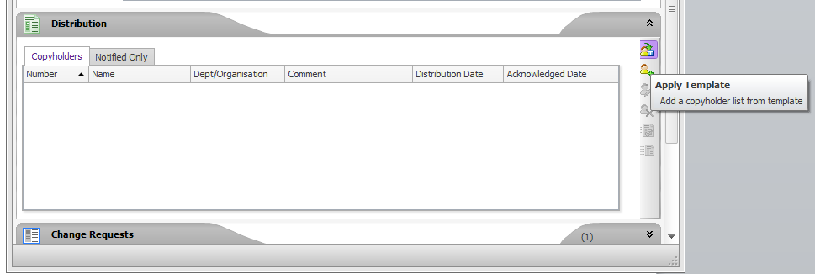

If prompted select the option to ‘Replace the existing copyholders’ in the list. This will bring in the most up-to–date list of people.

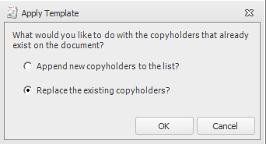

1. Remove any duplicate records (some people may appear on more than one template list) and remove any obsolete users.
2. Distribute the document and confirm the Distribution Date field is now populated.

All copyholders should also be set up on the Notified Only distribution lists for the documents. This ensures that they are able to easily find the documents after they have acknowledged them.

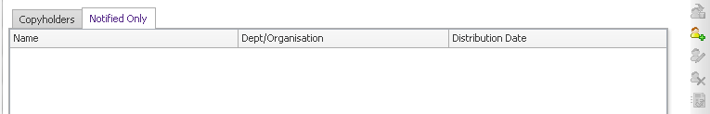

Note: The copy holder templates are not available to bulk load notified only users although some equivalent Reference Groups have been created to simplify the process. These can be accessed through the person search dialog.

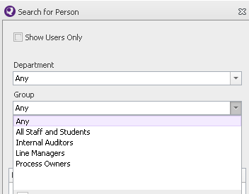

If the document is completely new the details including Distribution list details should also be updated into the Document Distribution section of this document.

* + 1. New Minor Document Version Distribution

The new version of a document will inherit the distribution list from its previous version. However, for a new minor document it is only necessary that copyholders that have not acknowledged a version since the previous major version release (e.g. For V2.0 this includes 2.0, 2.1, 2.2, 2.3 ….) are included in the distribution list for acknowledgment. To manage this, the process is as follows:

1. Run the report ‘Document Copy Holders and Acknowledgments’. Identify any people that have already acknowledged the document since the previous major version release e.g. if this document is version 2.4 identify any people that have acknowledged version 2.0, 2.1, 2.2, 2.3.
2. Remove the people identified from the current distribution list.
3. Distribute the document and confirm the Distribution Date field is now populated.

The Notified list is also inherited from previous document versions (major or minor) so no further action is required to complete the notify list and the distribution will be completed by the action above.

* + 1. Managing New Starters

New starters should be added to the appropriate Copyholders template(s) and Reference Groups for their role.

The new starter will need to be added to the distribution list for each document that their Copyholder template is applicable to.

This can be completed by either adding the person individually or re-applying the template but choosing the ‘Append New Copyholders to the list’ option (this will add all copyholders in the template so may create duplicates).

They should also be added to the Notified Only distribution list for the same set of documents.

There are some documents where the users will only need to be added to the Notified Only distribution (see section 4.6.1)

* + 1. Managing Role Changes

The person should be added/removed from the appropriate Copyholder template(s) and Reference Groups for their role.

If they have already acknowledged a document that is no longer in their scope they can be left in place. Otherwise the person should be removed from the distribution list for any documents no longer in their scope for the new role. They must also be added to documents entering their scope using the Managing New Starters process above.

* 1. Managing The Release of New Document Versions

1. Check for any typos or obvious errors.
2. Check any external references are correctly designated (i.e hyperlinks use English descriptor, not a url) and the link works.
3. Check that the document has been formatted correctly (using the built in ISMS styles where appropriate).
4. If there have been changes to the document layout, additional sections or pages check that the Table of Contents has been updated to reflect these changes.
5. Open the document record in Q-Pulse for the current version of the document.
6. Review all outstanding CRs and determine which will be included in the revision. In particular ensure that any CRs raised for minor corrections are included.
7. If the next release is to be a minor version, expand the ‘Distribution’ section and identify all users that have not acknowledged the current version of the document (see example below).

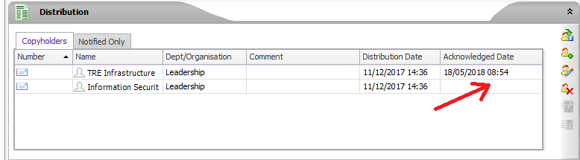

1. Prepare the comments for the Change Details. Include the numbers of the CRs that have been implemented with this release.
2. Ensure that the version number is set correctly (add 0.1 for a minor version e.g. 2.3 -> 2.4, increment to the next whole number for a major version e.g. 2.5 -> 3.0). All first versions of a document should be numbered 1.0.
3. Update the distribution list based upon any outstanding copyholders previously identified (for minor versions) or for all copyholders (major versions).
4. Following loading and distribution of the document check that the Related Documents are consistent with any references included in the document. 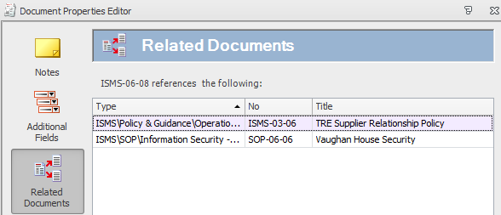
5. Check or add the Related Process for the document
6. Check or add any updated ISO controls (Related Standards) that are addressed by the document and update as necessary.
7. Check that the review date has been correctly set. For a major version this should be 2 years from the document active date. For a minor version, if no other review has been completed the review date should not be updated from the previous version. If a review has been completed the date can be updated and the following comment should be included in the Change Details “Next review date will be set from the active date of this minor version”
   1. Document Approval Templates

Q-Pulse provides a facility, through the Document Module to create and manage Approval Templates. These allow, for example, a standard list of approvers to be set up which are then automatically applied to each document the template is associated with. The association between the underlying document type and the templates is made through the Document Type Managed List.

There is currently only one template, Draft Actions, which is applied to all ISMS document types.

Due to the way major and minor document versioning is used with the different approval paths required for each, there are currently no default approvers set in the Draft Action template.

The template has been set to remove the requirement for documents to be ‘draft approved’ before activation. This reduces the steps to move a document from draft to active.

* 1. eMail Notification

eMail notification has been enabled for Q-Pulse. The following automatic notifications will be sent

|  |  |
| --- | --- |
| **Name** | **Module** |
| NC Created | CA/PA |
| NC Stage Added | CA/PA |
| NC Stage Owner Changed | CA/PA |
| Audit Scheduled | Audit |
| Audit Re-scheduled | Audit |
| All Audit Non-conformances Closed | Audit |
| Notify Approvers | Documents |
| All Draft Approvers Responded | Documents |
| New Active Revision Available | Documents |
| Notify Copy Holders | Documents |
| Change Request Raised | Documents |
| Competency Added | People |

Also the following escalations will be sent

|  |  |  |
| --- | --- | --- |
| **Name** | **Type** | **Module** |
| Audit Due | Reminder | Audits |
| Audit Overdue | Overdue | Audits |
| Non-Conformance Due | Reminder | Incidents |
| Stage Due | Reminder | Incidents |
| Stage Overdue | Overdue | Incidents |
| Draft Document with Outstanding Approval Overdue | Overdue | Documents |
| Change Request Not Actioned | Overdue | Documents |
| Document With Outstanding Acknowledgement | Overdue | Documents |
| Document Due Review | Reminder | Documents |
| Competency Due | Reminder | People |
| Competency Overdue | Overdue | People |

Note: If any images are to be included with the message text, ensure that these are not linked or referencing network locations that are inaccessible to Q-Pulse. This will cause the message to error and not be sent. Also ensure the detail bands are included for any repeating sections since it has also been advised that messages will fail if these are excluded.

When new draft documents are created and sent for approval it should be noted that the Change Details (the text) can only be added to a draft document after it has been created. In order for the Notify Approvers eMail to include any change details associated with the document version in the message that is sent, the wizard option to automatically distribute a new draft to approvers should not be selected. Distribution to approvers should be completed as a separate activity after the draft document has been created.

* + 1. eMail Considerations for External TRE Users

The following change should be made to accommodate External TRE Users that do not have an account to access Q-Pulse.

If an email address is available for the person record it can be stored in the email1 field. However, the person record should be saved with a blank email2 active. With a blank email set active messages will not be sent to the external users.

* 1. Testing and Change Control
     1. Q-Pulse Testing

There is no separate test environment for Q-Pulse so any testing will be completed in the same environment as the live system. Therefore all testing must be carefully planned and executed to minimise any impact on the live system.

Two user accounts will be available for the test of Q-Pulse functionality.

* ResearcherA – assigned primary licence
* TestA – assigned secondary licence

The security permissions that are applied to these accounts can be from existing security groups, applied directly or applied using permissions assigned to the ‘Test’ group.

If a document is needed for testing, an existing document may be used if the testing is not going to have a material impact e.g. can a user view a document.

When testing is going to have a more significant impact e.g. taking a document through its full lifecycle or adding change requests, a test document should be created using the TEST document type.

Since there is no separate test environment, following the completion of a test any obsolete records should be removed otherwise these could be available to users.

* + 1. Q-Pulse Change Control

Any administrative changes to the Q-Pulse system will be managed through a simple change control process. This excludes standard Q-Pulse activities e.g. the addition of new documents.

All system changes will be recorded and any associated system documentation updated to reflect the changes.

Where the change impacts a process, approval from the associated process owner will be necessary to complete the change.

Where the change impacts the whole system approval will be provided by the ISM.

All other changes may be approved and implemented by the Q-Pulse system administrator.

[Q-Pulse Change Control Log](https://elab.herc.ac.uk/share/page/site/tre/document-details?nodeRef=workspace://SpacesStore/57126737-bf46-4d14-bd4b-ffe4857f8665)

* 1. Configuration Changes

This section includes details of administration changes that have been made to the standard Q-Pulse system.

* + 1. Managed Lists, Custom Fields and Preferences

The detail of settings for all Managed Lists, Custom Fields and Preferences should be recorded. The record can be found in eLab:

[Managed Lists and Custom Fields](https://elab.herc.ac.uk/share/page/site/tre/document-details?nodeRef=workspace://SpacesStore/32e4d7e7-c55b-4834-a469-eee7d6d574e5)

* + 1. Wizards and Templates

The details of settings for all Wizards and Templates can be found in eLab:

[Wizards and Templates](https://elab.herc.ac.uk/share/page/site/tre/document-details?nodeRef=workspace://SpacesStore/030ca6a1-6d2f-499e-b7f9-e399aa0fa2c9)

* 1. Managing Audit Records
     1. Internal Audits Scope Items

Internal audit scope items should be added in the following way:

* Add the related process for the audit.
* Set the process as the primary scope of the audit, discarding all current scope items. This will add the latest selection of the related documents to the scope

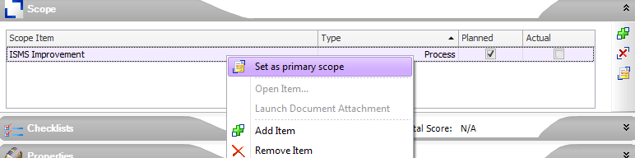

* Identify which controls are relevant to each document and add these controls (Area of Standard) to the scope.
* As the control items are for information and are not being directly audited, untick the ‘Planned’ checkbox
  + 1. RMM Audit Checklists

The RMM Audit Checklists are managed through the audit Question Bank. If a Process Owner wishes to update an RMM audit measure the change should be made through the Question Bank. The updated checklist should then be re-applied to all scheduled RMM audits for that process.

1. Cross-referenced ISMS Documents

|  |  |  |
| --- | --- | --- |
| Number | Type | Title |
| <NO DATA> | <NO DATA> | <NO DATA> |

1. Appendices

None